Register as a User on the Department of Labour Website
- Introduction
Purpose

The purpose of this document is to take the Department of Employment ad Labour Clients through User registration process to become a transactional user on any of the Departments Applications/Systems of their interest.
Business Scenario

The Employer/Healthcare Provider/3rd Party registers themselves as users on the Departmental Website.
Prerequisites

The clients needs to have access to the Internet in order to reach the Department of Employment ad Labour Website on the following link:
www.labour.gov.za

- Registration Process
  - Step1
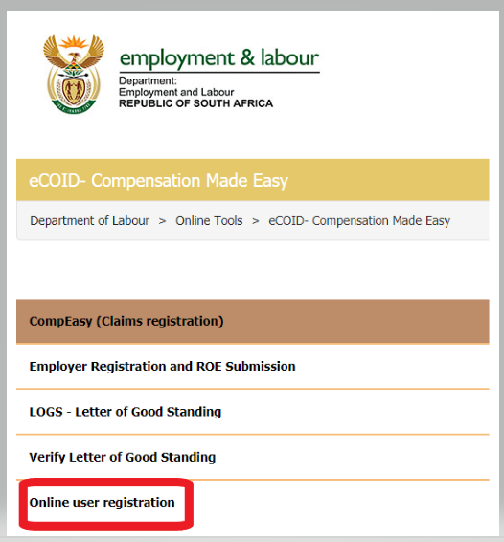

  - Step 2
Key-in the ID number on the “ID Number” field and click the “Get Individual” button, the person’s First Names and Surname will be populated.

Complete the contact details section a click the “Submit” button.

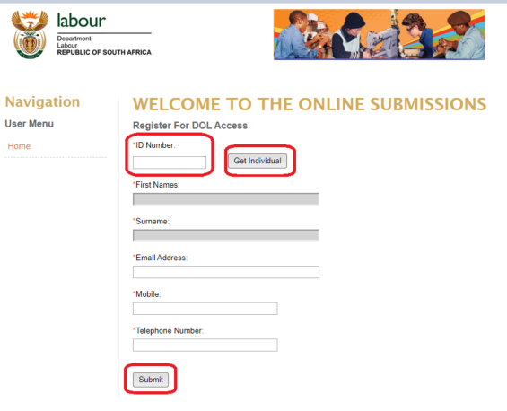

  - Step 3
Once all the details are correctly captured and submitted, the following confirmation message will be displayed on the Client’s screen, subsequent to that the Client will receive an e-mail with their login credentials (Username and Password).

NB: The credentials may NOT be used to log on to CompEasy, the Client needs to register as a user on the CompEasy system, It takes up 24 Hours to allow this process to complete.
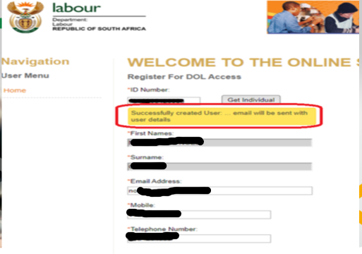
  - Register as User on CompEasy
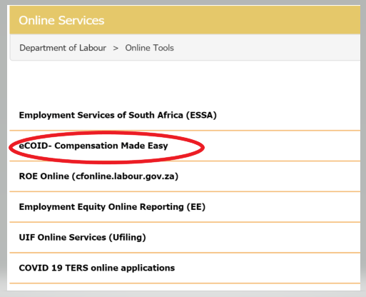

  - Click on External User Registration
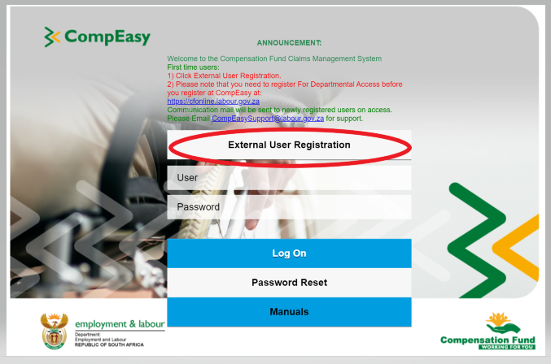

  - Complete the user registration form, all fields with an asterisk (*) are required to be filled.

  - Attach all required document for user registration
  - Click the Submit for Approval button to submit for approval

  - The following message will pop up, the user will get correspondence (Approved/Rejected) via the e-mail that is registered at DoL with 7 working days.

  - Once the user has been granted access, they will receive the following e-mail confirmation.
